**Sprint Review**

**Items completed**

1. Created a Trello board
2. Make a basic Gantt chart
3. Create a level 0 design
4. Decided on a project (The Weather Station)
5. Held group meetings
6. Create a BOM
7. Purchased components
8. Built a working prototype
9. Wire and code LEDs
10. Design and build a final enclosure
11. Connect to internet
12. Wire and code LCD screens
13. De-bug

**Items not completed**

1. Portable/ recharging capabilities

**Backlog**

1. Design an enclosure
2. Weekly team meetings
3. Code the LEDs
4. Code the LCD screens
5. Issues soldering between LEDs
6. Issues pairing the LCD screens
7. Issues connecting to Wi-Fi

**Project Difficulties**

* Items that caused the most difficulties (1 paragraph)

One of the items that caused the most difficulties was the programming of the LEDs. Because the provided example functions from the Adafruit NeoPixel library commonly used delay() functions, this interfered with the ability for the ESP32 to get new updated data from the Adafruit.io website. This had to be solved by replacing these functions with new custom functions that would update when the internal clock time increased to greater than a particular time interval, (for example, 30 milliseconds). This sped up the running of the program, so it could get in and out of a function to update the lights much faster (as fast as the CPU could complete simple math and assignment operations), and had the ability to check for new data constantly. Another issue with the lights were dead or dying LED pixels. Certain LEDs behaved in unexpected ways, for instance randomly turning green, or flashing some other color. This behavior didn’t make sense in light of the code at all, and so we had to conclude that some LEDs in our strip simply were bad. Whether or not they arrived that way, or ended up that way because of incorrect operation, we aren’t fully sure about, and wouldn’t be unless we did testing with a full new strip. We hypothesized the issue might have to do with the fact that NeoPixels are meant to be used with Arduinos which provide a 5V data output. The ESP32 produces a 3.3V data output, and though we were powering the LEDs with 5V, with the difference in voltages between Vcc and data might have damaged the pixels. We implemented a leveling shifting chip, to shift from 3.3V to 5V, but by the time that was implemented, the damage was already done.

**Subsequent Sprint**

* What would we do in our next sprint? What items would be removed from the backlog (1 paragraph)

If we were to do another sprint we’d probably work on knocking out some of the current bugs, which include the fact that it works properly for a few hours before eventually freezing. And we would test a new strip of NeoPixels with the level shifter we have installed to see if it still produces broken pixels. Some members would likely continue working with trying to get portable power working or playing around with the TFT screen to get other display items on it.

**Individual Skills Learned**

Team Member Jesse Vazquez

As a result of this project, I feel like I have personally gained a better understanding to coding a simple program, soldering, and using the available equipment offered for use at PSU. By following along and observing my team members work and debug existing code. I have learned different approaches to tackling problem code as it arises. Through trial and error I feel more confident when it comes to soldering. The most important skill I learned was the fact that we have available equipment we can use for free while enrolled at PSU such as 3D printers, laser cutters, and various power tools.

Team Member Chuck Faber

Through this project I got to learn a lot more about how microcontrollers run through code and different small things that can trip it up. I learned how to optimize code for speed so that multiple processes could be run simultaneously, and also how to use level convertors to shift up voltage of a data line. I also learned how to create a laser cut box, as this is the first time I’ve done something like that.

Team Member Matt Wilson

Throughout my work on the project, I learned more about processor protocols when interfacing with peripheral devices so that I could interface a TFT LCD screen with our microcontroller. I learned that a ‘master’ device can control many ‘slave’ devices with only a clock signal and serial data signal, which is used in I2C protocol. I also learned that many processors can use most of their GPIO pins to implement serial data transfer protocols as well. Since the built-in serial protocol pins were not working with the LCD screen libraries, I had to resort to finding a library that would support any GPIO pin for the controller-peripheral interface. Once I was successful, it was pretty entertaining to learn the graphics library functions from the provided sample codes to create a suitable screen for our project.

**Sprint Retrospective**

* Discussion of sprint planning (2 paragraphs)

We started out by trying to determine a project we all wanted to work on. After that, we tried to determine what features we wanted in our product, and how many of those could be reliably delivered, and were within our budget of cost and time. After that, we broke out the tasks into logical chunks, and assigned them to people based on their enthusiasm for the task or prior experience. Each chunk was given a deadline, and smaller tasks were used for creating checklists if necessary.

We decided upon creating two prototypes, the second of which would be our final prototype. Each prototype would be 1 sprint which would take 1 week. Based on this timeline, the deadlines for each task were chosen. For team organization and project planning, we primarily used Trello, as directed by Dr. Brano. However we also created a Gantt chart in Google Sheets (**Figure ??**) to get a bird’s-eye-view of the project and deadlines. We primarily communicated face to face in class or during our team meetings. We also used a group text to communicate digitally. Our Scrum Master was Dr. Brano, and he helped us figure out the format of typical Scrum stand-ups and how to review our progress in the project.

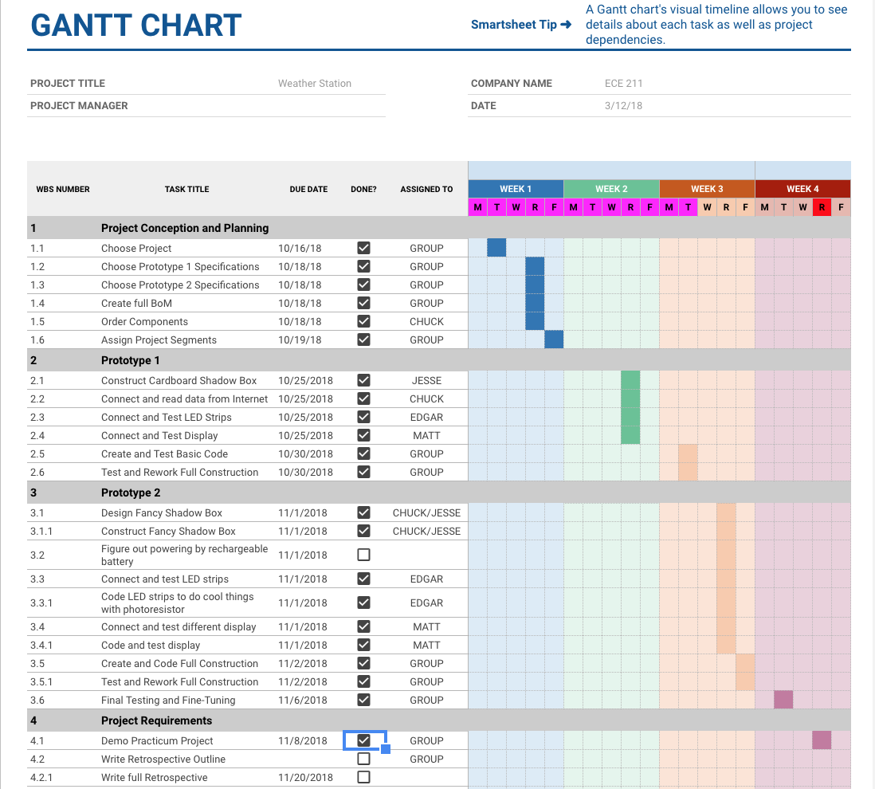

* What went well and what didn’t? How will we improve our process? (1 Paragraph)

Things that went well in the project was that we had tight turn-around on various group tasks. Everyone was committed to getting their part done in a timely manner. And everyone was great about communicating their progress to the rest of the group. Our face-to-face weekend meetings were always very productive and it was very helpful to have everyone there to get the final touches put on each of our prototypes. We believe it was also a good idea to have two prototypes. This really helped us be ready with a great product by the demonstration day. We felt that if things didn’t work out with our second more advanced prototype, we could always fall back on our first more basic prototype, but it also helped in the sense that we got a basic grasp of how things would work together by building the first prototype, so that the second prototype was much easier than it would have been otherwise. To improve our process, we think having more frequent check-ins, maybe using video conferencing would be useful. This would help us to gauge progress and to figure out if anyone has any roadblocks keeping them from moving forward that the rest of the group might be able to help them out with.

* Screenshot of the final Trello board

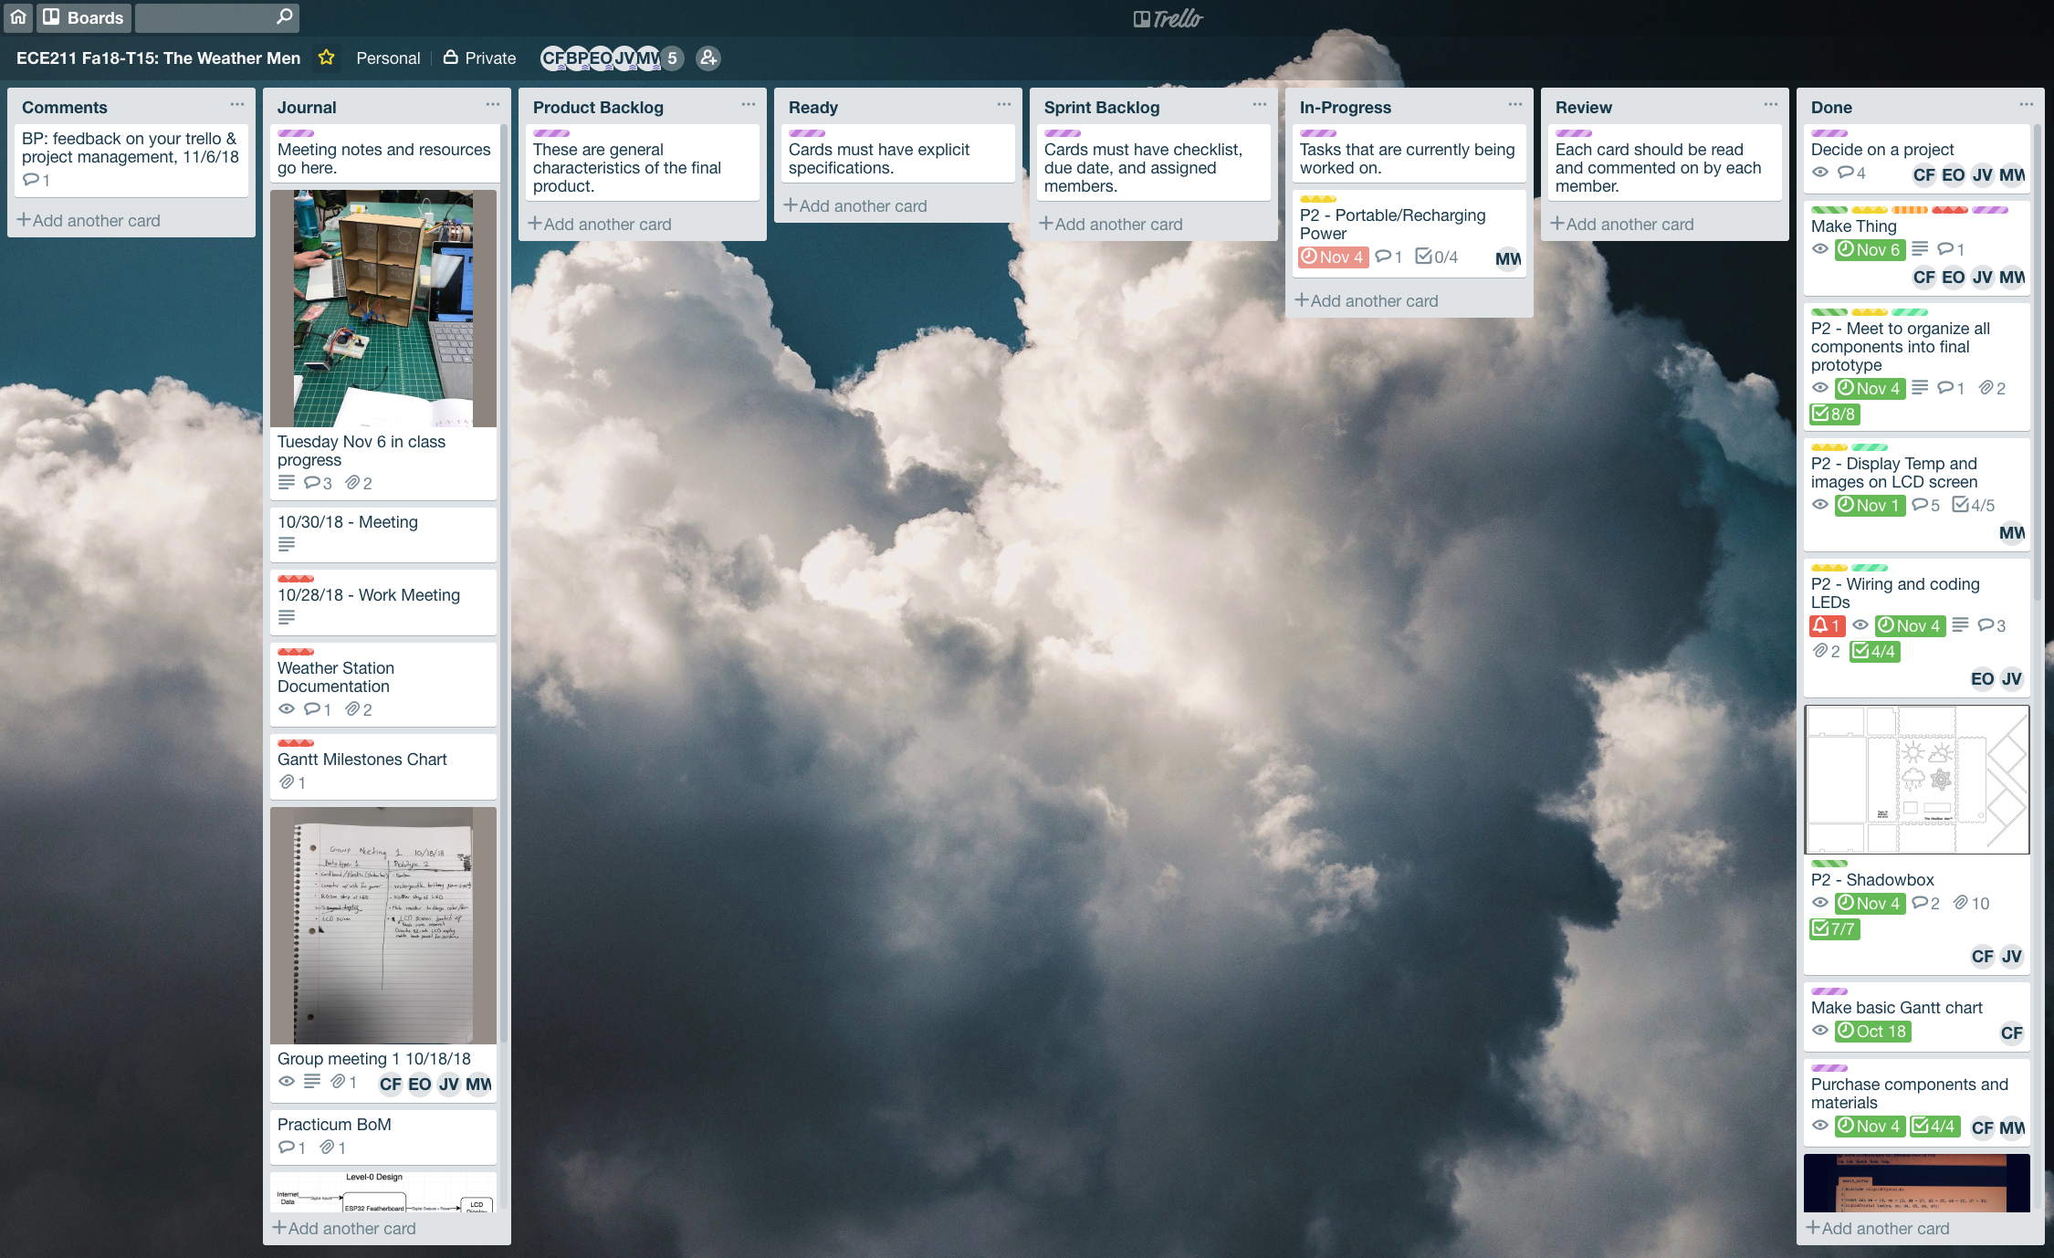

***Fig 10: Trello Board***

* What would you do to make a better Trello board (1 paragraph )

As a team we benefited from the fact that group member Chuck Faber had some prior experience with Trello. As a result he took charge of the layout and design of our Trello board. This cut the learning curve involved when dealing with a new tool tremendously. One thing that we as a group can do to make a better Trello is to ensure that future Trello boards created have equal involvement from every team member.

* Trello conclusion

Overall, we would give ourselves a score of 95 for how well this sprint went. Our team The Weathermen met with our Scrum Master Professor Branimir on Tuesday October 23rd and then again on Tuesday October 30th. We discussed Sprint Review and Sprint Retrospective. We feel that our overall process was clear and concise. We met all of our deadlines and kept our board up to speed with any change that arose during the design process.